**Day 1:**

**1.)%{**

**%}**

**%%**

**[A-Z] {printf("%c",yytext[0]);}**

**. {}**

**%%**

**int yywrap(){}**

**int main()**

**{**

**printf("\nenter the string:");**

**yylex();**

**}**

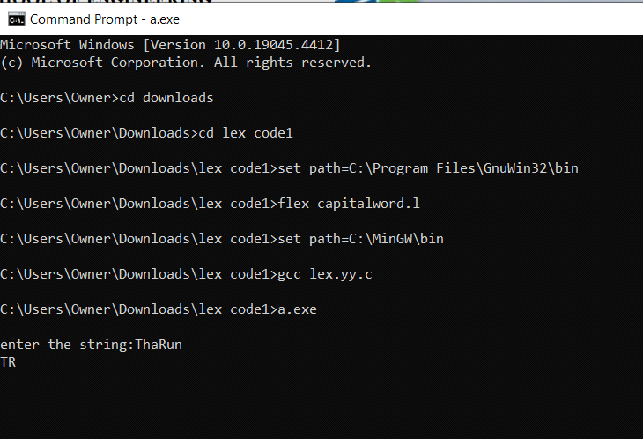

**2.)**

**%{**

**#include<stdio.h>**

**%}**

**%%**

**[0-9]+ {printf("%s,is a digit",yytext);}**

**.+ {printf("it is not digit");}**

**%%**

**int main()**

**{**

**printf("\n enter the digit:");**

**yylex();**

**}**

**int yywrap()**

**{**

**return 1;**

**}**

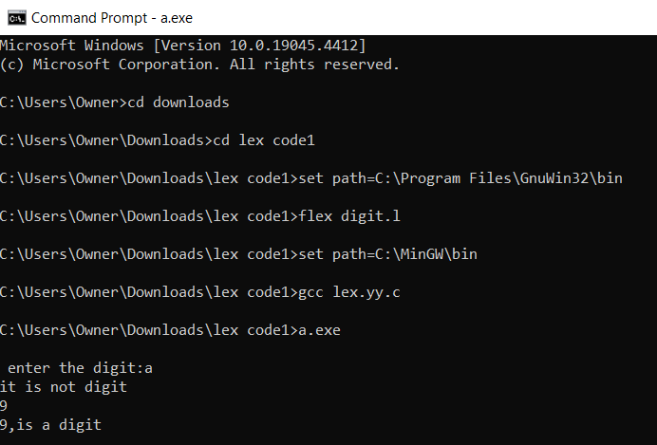

**3.)%%**

**[1-9][0-9]{9} {printf("\nmobile number is valide:");}**

**.+ {printf("\nmobile number is invalide:");}**

**%%**

**int main()**

**{**

**printf("enter the number:");**

**yylex();**

**return 0;**

**}**

**int yywrap()**

**{}**

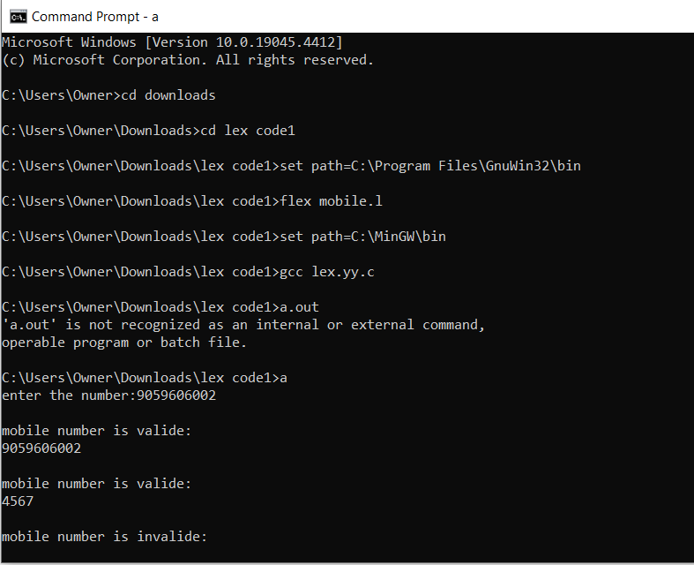

**4.)%{**

**int vow_count=0;**

**int const_count=0;**

**%}**

**%%**

**[aeiouAEIOU] {vow_count++;}**

**[a-zA-Z] {const_count++;}**

**%%**

**int yywrap(){}**

**int main()**

**{**

**printf("enter the string of vowels and consonents:");**

**yylex();**

**printf("number of vowels are:%d\n",vow_count);**

**printf("number of consonents are:%d\n",const_count);**

**return 0;**

**}**

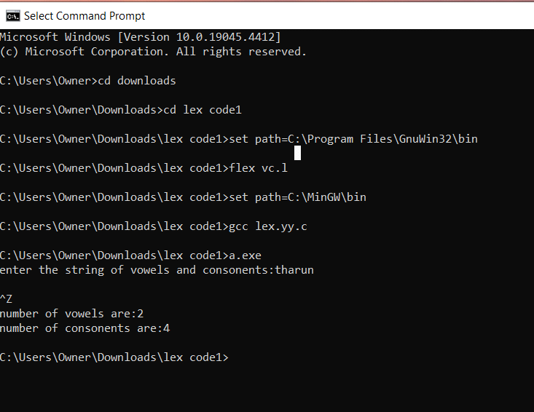

**5.)**

**%{**

**%}**

**%%**

**[a-zA-Z][a-zA-Z0-9]+ {printf("\n is identifier",yytext);}**

**.+ {printf("\n%s is Keyword",yytext);}**

**%%**

**int yywrap(){}**

**int main()**

**{**

**printf("Enter the input:");**

**yylex();**

**}**

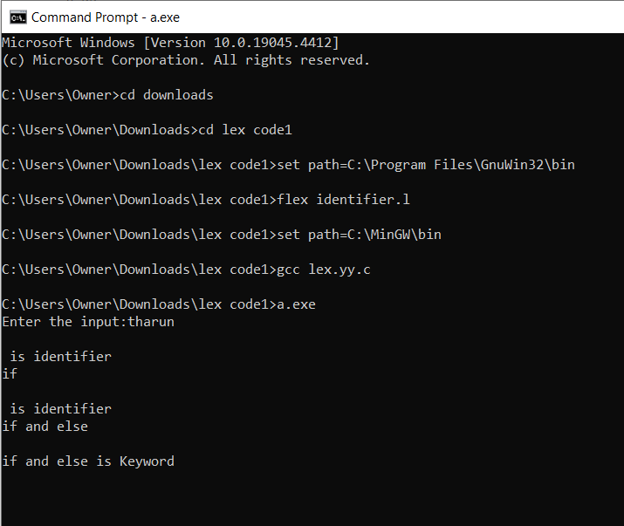

**6.)%{**

**int positive_count = 0;**

**int negative_count = 0;**

**%}**

**DIGIT [0-9]**

**SIGN [-+]**

**%%**

**{SIGN}?{DIGIT}+ {**

**int num = atoi(yytext);**

**if (num > 0)**

**positive_count++;**

**else if (num < 0)**

**negative_count++;**

**}**

**.|\n ; /* ignore any other characters */**

**%%**

**int yywrap() {**

**return 1; // Indicate end of input**

**}**

**int main(int argc, char **argv) {**

**yylex();**

**printf("Positive numbers count: %d\n", positive_count);**

**printf("Negative numbers count: %d\n", negative_count);**

**return 0;**

**}**

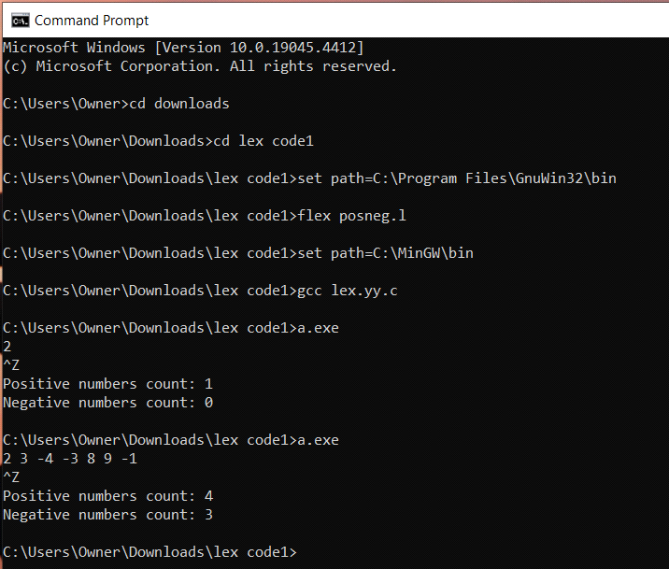

**8.)%{**

**#include <stdio.h>**

**%}**

**VOWEL [aeiouAEIOU]**

**LETTER [a-zA-Z]**

**%%**

**{VOWEL}{LETTER}* { printf("Valid string: %s\n", yytext); }**

**.|\n ; /* ignore any other characters */**

**%%**

**int yywrap() {**

**return 1; // Indicate end of input**

**}**

**int main(int argc, char **argv) {**

**printf("Enter a string: ");**

**yylex();**

**return 0;**

**}**

